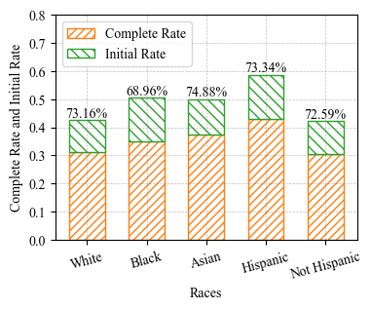

**Figure C.** The completeness of the HPV vaccinated individuals on the Long Island, New York State, 2012-2023. The figures are generated according to the CDC HPV vaccination guidelines.

1. The Nested Pie Chart shows the HPV Vaccination Patients Doses Schedule and Completeness Portion.

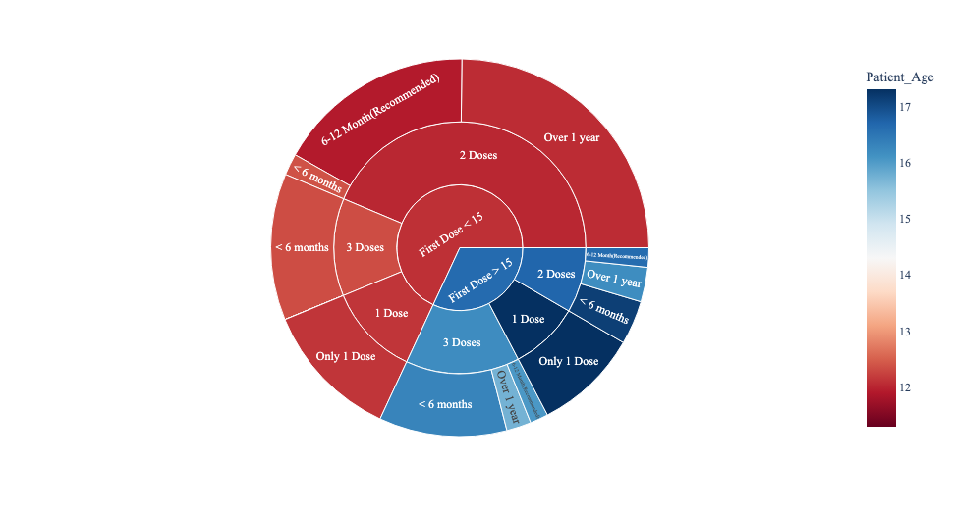

1. Gender Disparity of Completeness
2. Race Disparity of Completeness

